Handout 1.11: Label Scavenger Hunt
Lesson: 1.11 Label Detective, Day 1 Print: Pages 1 to 3, one per student. Page 4 (five written-out labels) only if real packages are not available; one per station.

Page 1: The parts of a label
Name: ______________________________ Date: ______________ Period: ______
Directions: As we walk the label on the screen, write the name of each part on the line next to its letter.
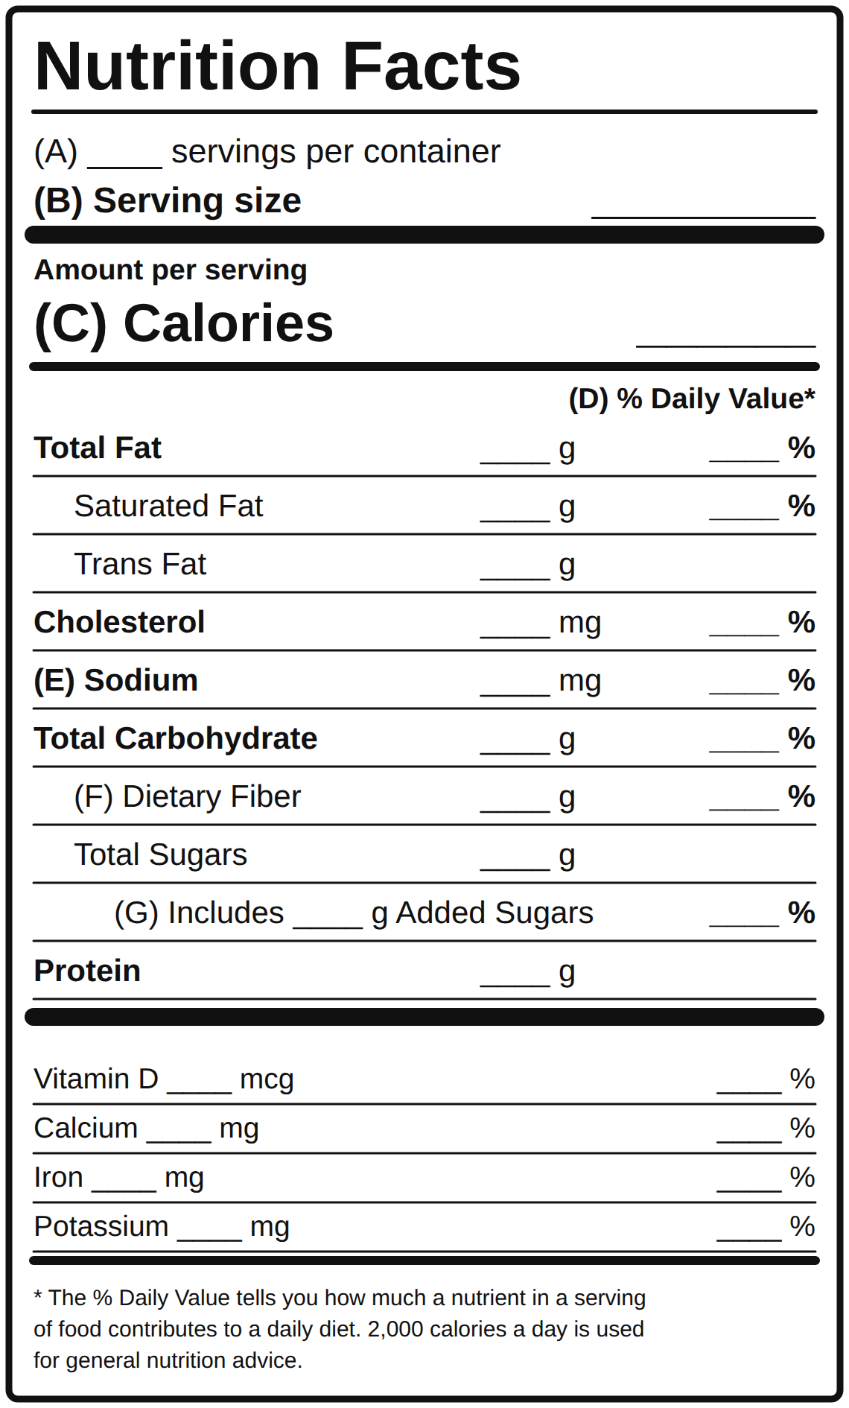
A blank Nutrition Facts label with the parts marked A to G
A. ______________________________ (how many servings in the whole package) B. ______________________________ (the amount all the numbers describe) C. ______________________________ (energy in one serving) D. ______________________________ (how much of a full day one serving gives, based on 2,000 calories) E. ______________________________ (a nutrient to get less of; salt) F. ______________________________ (a nutrient to get more of; keeps you full) G. ______________________________ (sugar the company put in)
Word bank: serving size, servings per container, calories, percent daily value, sodium, dietary fiber, added sugars.
From the label on the screen: Serving size ____________ Calories ____________ Three nutrients and their amounts: ____________, ____________, ____________
The 5 and 20 rule. 5% DV or less is LOW. 20% DV or more is HIGH.
- Low is good for the get less list: saturated fat, sodium, added sugars.
- High is good for the get more list: dietary fiber, vitamin D, calcium, iron, potassium.
Practice on the screen label: Sodium is ______% DV, so it is low / in between / high. Fiber is ______% DV, so it is low / in between / high.
The servings trap. If the package has ______ servings and you eat the whole package, multiply every number by ______.
Screen label: calories in the whole package = ______ x ______ = ______. Sodium in the whole package = ______ x ______ = ______ mg.

Page 2: The hunt, part 1: record the facts
Directions: Your station has five packages. Read the Nutrition Facts on each one. Fill in one row per package. Serving size first, then everything else.
Package name | Serving size | Servings per container | Calories per serving | Sodium (mg and % DV) | Added sugars (g and % DV) | Dietary fiber (g and % DV)
1.
2.
3.
4.
5.

Page 3: The hunt, part 2: find it
Directions: Use your table. Every answer needs a package name AND a number. A number is evidence. “It looks unhealthy” is not.
- Which package has the MOST sodium per serving? Package: __________________ Number: ______ mg (______% DV)
- Which package has the FEWEST servings per container? Package: __________________ Number: ______
- Find one package with 20% DV or more of anything. Package: __________________ Nutrient: __________________ ______% DV. Is that good or bad for this nutrient? Why? _______________________________
- Find one package with 0 g added sugars. Package: __________________ (If none, write “none at this station” and name the lowest: __________________ ______ g.)
- Which package has the MOST dietary fiber per serving? Package: __________________ Number: ______ g (______% DV)
- Which package would you pick for an after-school snack? Package: __________________ Two numbers that back you up: ______________________ and ______________________
Grade 8 stretch: pick a package that gives fiber in grams only. Compute the % DV: grams ______ divided by 28, times 100 = ______%. Does your answer match the label? ______

Page 4: Five written-out labels (use only if there are no real packages)
Package 1: Frosted Corn Flakes cereal. Serving size 1 cup (37 g). Servings per container about 10. Calories 140. Total fat 0 g (0%). Sodium 180 mg (8%). Total carbohydrate 34 g (12%). Dietary fiber 1 g (4%). Total sugars 13 g. Includes 13 g added sugars (26%). Protein 1 g. Iron 8 mg (45%). Front says: “Fat free. Good source of 8 vitamins and minerals.”
Package 2: Classic Potato Chips, party size bag. Serving size 1 oz (28 g, about 15 chips). Servings per container about 13. Calories 160. Total fat 10 g (13%). Saturated fat 1.5 g (8%). Sodium 170 mg (7%). Total carbohydrate 15 g (5%). Dietary fiber 1 g (4%). Total sugars less than 1 g. Added sugars 0 g (0%). Protein 2 g. Potassium 350 mg (8%). Front says: “Made with real potatoes. Gluten free.”
Package 3: Chicken Noodle Soup, condensed can. Serving size 1/2 cup condensed (120 mL). Servings per container about 2.5. Calories 60. Total fat 1.5 g (2%). Sodium 890 mg (39%). Total carbohydrate 8 g (3%). Dietary fiber 1 g (4%). Total sugars 1 g. Added sugars 0 g (0%). Protein 3 g. Front says: “Made with real chicken.”
Package 4: Blue Sports Drink, 32 oz bottle. Serving size 12 fl oz (360 mL). Servings per container about 2.5. Calories 80. Total fat 0 g. Sodium 160 mg (7%). Total carbohydrate 21 g (8%). Dietary fiber 0 g. Total sugars 21 g. Includes 21 g added sugars (42%). Protein 0 g. Potassium 45 mg (0%). Front says: “Electrolytes. Rehydrate and refuel.”
Package 5: Oats and Honey Granola Bars, box of 6 packs. Serving size 2 bars (42 g). Servings per container 6. Calories 190. Total fat 7 g (9%). Saturated fat 1 g (5%). Sodium 160 mg (7%). Total carbohydrate 29 g (11%). Dietary fiber 2 g (7%). Total sugars 11 g. Includes 11 g added sugars (22%). Protein 3 g. Iron 1 mg (6%). Front says: “100% natural whole grain oats. No high fructose corn syrup.”

